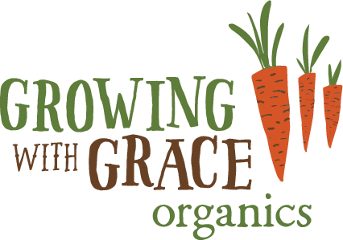 Share Application Form

Please complete all parts of this form and return with your cheque to: - The Secretary, Growing with Grace, Clapham Nurseries, Clapham, Lancaster LA2 8ER

First Name ........................................................

Surname ................................................................

Address ..................................................................................................................................................

.............................................................................

Post Code .............................................................

Email Address: - ....................................................................................................................................

Telephone: - Landline ........................................................Mobile .......................................................

Number of £1.00 shares I wish to purchase:-

£100 £200 £500 £1,000 £2,000 £5,000 £10,000

Other: - (Minimum £100) ..............................................................................................................

I enclose a cheque, payable to ‘Growing with Grace Share Issue’ for:

£ ...............................................
Payments by bank transfer are welcome.
Bank Transfers - Growing with Grace accounts details - Sort Code 08 92 99 & Account No. 69116883
Please make your surname and shares your bank transfer reference - e.g. Smith Shares

Acknowledgement will be made 10 days after receipt, by email or by post where no email available

Your agreement
- I am 16 years old or over
- I have read the terms and conditions of the share offer. I agree to be bound by these terms and conditions, and the rules of Growing with Grace
- I understand that Growing with Grace may reject the application and is not required to inform me of its reasons
- The data on this form will be stored on a computer database. It will only be used for Growing with Grace purposes
- It is a condition of this share offer that to ensure compliance with Money Laundering Regulations 2003, Growing with Grace may at its absolute discretion require verification of identity from any investor.

SIGNED AS A DEED

Name ......................................................................................... (Please print in BLOCK CAPITALS)

Signature ......................................................................
Date ............................................................................

------------------------------------------------------------------------------------------------------------------------------------------------
For office use: -

Date cheque received: ......................................................................
Cheque No: ...............................................................

Acknowledgement emailed/posted ....................................................
Entered on database .................................................

Share Certificate issued & posted ....................................................

